Digital Clock Operational Manual

# Getting Started

Before the operation of the clock, first check if the set contains all the required materials. The clock should include:

* The clock face
* Universal remote
* AC power cable
* CD containing PC software

If any of the listed materials are missing or faulty, please contact the supplier and a replacement product will be issued. In order to utilise the clock to the fullest extent, a PC is required however the clock can be fully utilised without a PC.

# Reading The Clock

The clock has a unique clock face, unlike that of any previous analogue/digital clock faces available. It may be difficulty initially to read the face, but it is simpler than it looks. The face is depicted below.

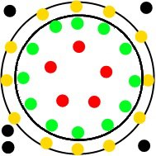

The clock face contains a total of thirty LEDs and three sensors each with a unique function. The three black dots on the left are all sensors with the top one being an optical sensor for PC transmission, the middle one being an infrared sensor for receiving transmissions from the remote and the bottom one being a light sensor to detect ambient light to adjust the clock face accordingly. The top right black dot on the face indicates whether the alarm is activated and the bottom one indicated whether the time is in am or pm.

To read the time, the user must know what the LEDs represent. The outer loop represents the minutes from 0 to 60 in five minute intervals. The middle loop represents the hours from 1 to 12 in one hour intervals. Finally the inner loop of four LEDs represents the minutes in between the five minute intervals displayed in the outer clock. Reading the hour is simply the same as reading the hour on a normal clock. To read the minutes, you first need to read the outer ring LEDs, which correspond to the same values as on a normal analogue clock. However this only provides a time to the nearest five minutes. To gauge a more accurate time, the inner ring has been included. The inner ring displays how many minutes past the minutes displayed on the outer ring. For example if the eighth LED on the outer ring, the sixth LED on the hour ring and 2 LEDs in the inner ring are activated, the time is 6:42. If no lights are activated in the inner ring, the time is exact to the five minute interval displayed on the outer ring.

# The Remote

For ease of access, a remote has been includes that can set the time and alarm and is depicted below.

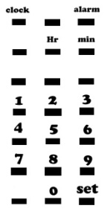

To set the clock, press and hold the clock button. This will allow the hour and minute values to be altered. To set the hour, press the hour button and enter the hour in 24 hour time with 0:00 being midnight and press the set button when complete. When setting the hour two digits must be entered so 5 o’clock in the morning would be 05. To set the minutes, press the minute button and enter a minute value between 00 and 59 and press the set button when finished. As with the hours, two digits must be entered when setting the minutes. When finished press and hold the set button to confirm the time. To set the alarm simply press and hold the alarm button and follow the same process as setting the clock.

# PC Application

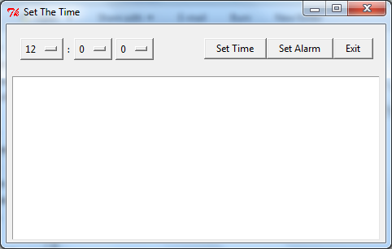In addition to the remote, a PC application has been included to allow the setting of the time and alarm via a PC.

To set the time, click on the dropdown menus on the top left and select a desirable time. Once a time has been selected, the choice to set the time or set the alarm is offered. After an option has been selected, a message box will appear asking the user to hold the clock up to the screen. The large white canvas will subsequently flash several lights and colours to transmit the time to the clock.

